Contents

Jointly distributed Probability distributions 2

Ex. Of joint probability distribution 2

Discrete bivariate distributions: 4

Joint probability distribution example: 4

Ans: 4

Continuous Bivariate distribution: 6

Ex: 7

Marginal distribution discrete case: 9

Marginal distribution continuous: 11

Marginal distribution example: 11

Expectation and variance of a marginal distribution of discrete variable: 13

Independent Random Variable for a discrete random variable: 14

Independent Random Variable for a continuous random variable: 14

Example of independent random variable for discrete variable: 15

Quiz: 16

Conditional probability of a joint probability mass function: 17

example of conditional probability mass function: 17

Conditional distribution – continuous case 19

Ex of continuous conditional distributional function: (Height of the person given calculate the persons weight) 19

Expectation of conditional probability mass function: 21

Conditional expectation of Continuous case: 21

Example for conditional expectation for probability dense function: 22

The expectation of conditional probability E[y/x] is nothing but the function of x i.e considered as g(x): 24

Jointly distributed Probability distributions:

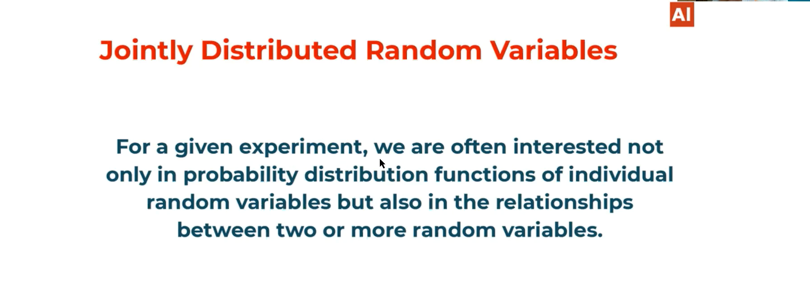

Ex. Of joint probability distribution:

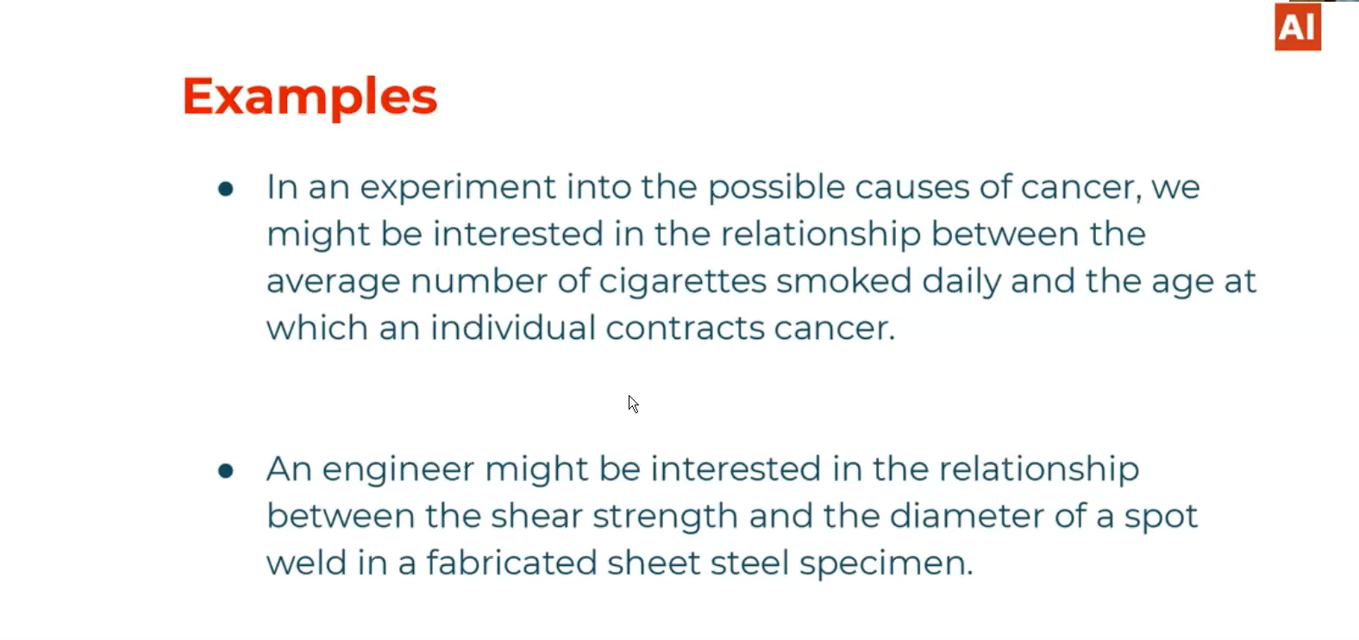

X1-> 1-D Discrete random variables

X2-> 1-D Discrete random variable

[X1,X2]🡪 2-D random variable

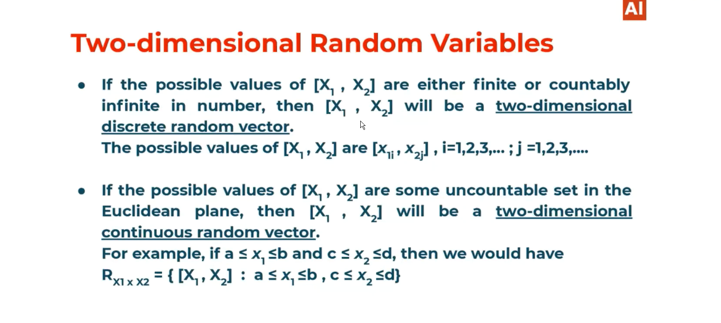

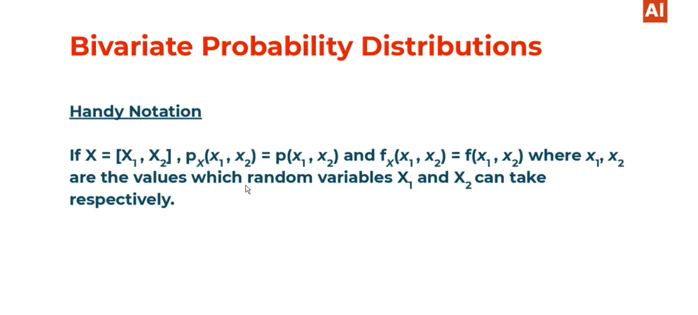

# Discrete bivariate distributions:

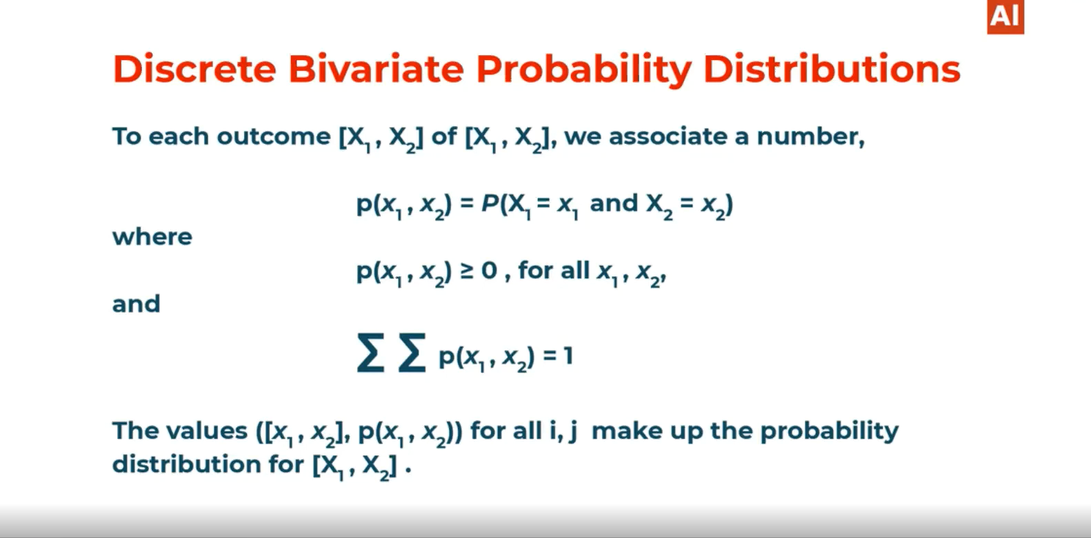

# Joint probability distribution example:

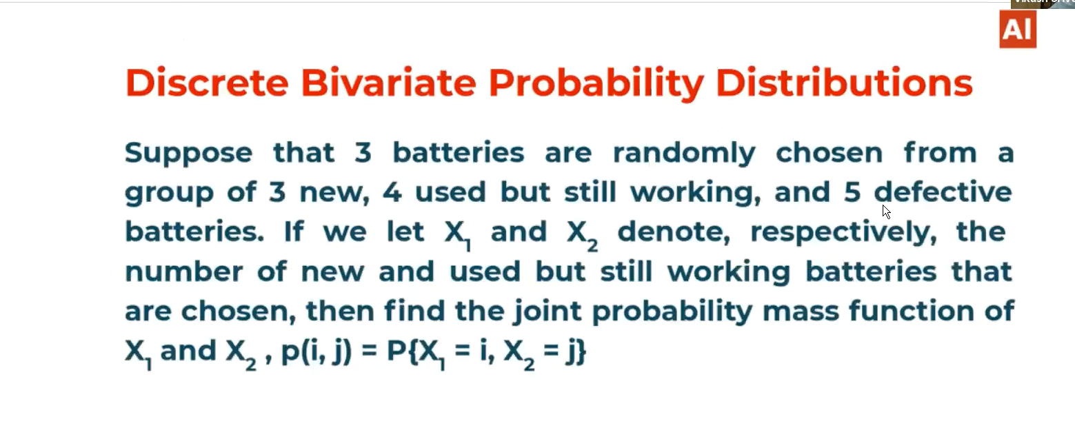

# Ans:

P(0,0)=0 batteries out of 3 new batteries and 0 batteries out of 4 new used working batteries and at the last 3 out of 5 defective batteries which is not considered as new or used as stated in the problem statement.

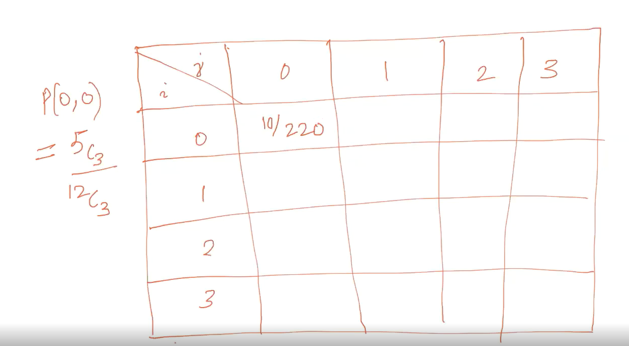

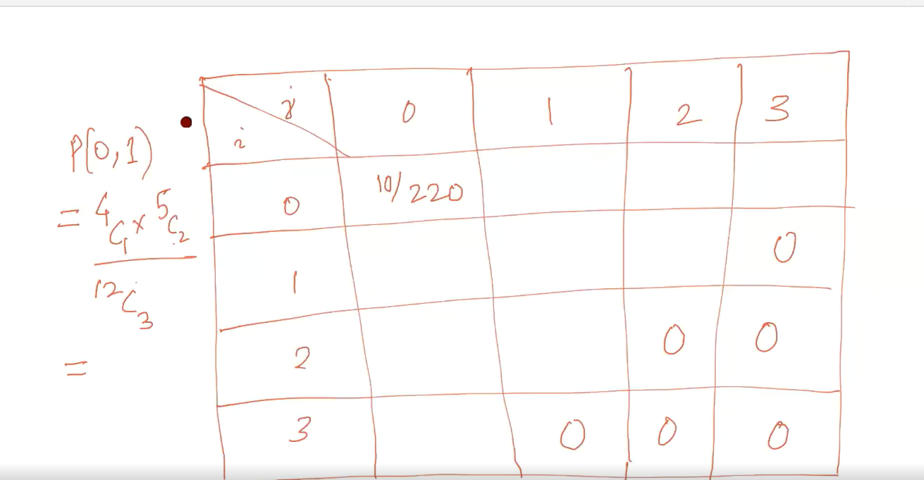

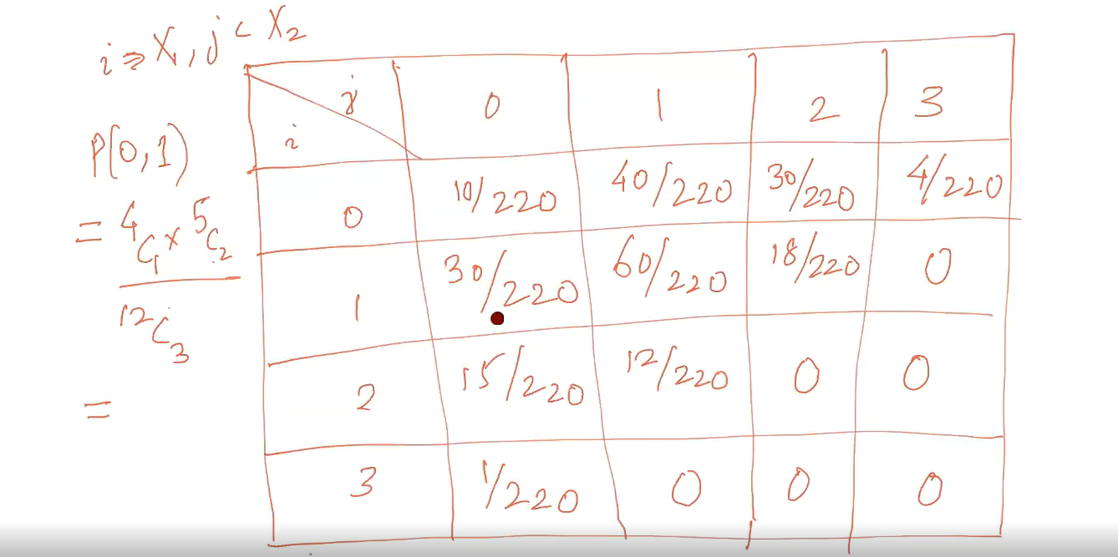

# Continuous Bivariate distribution:

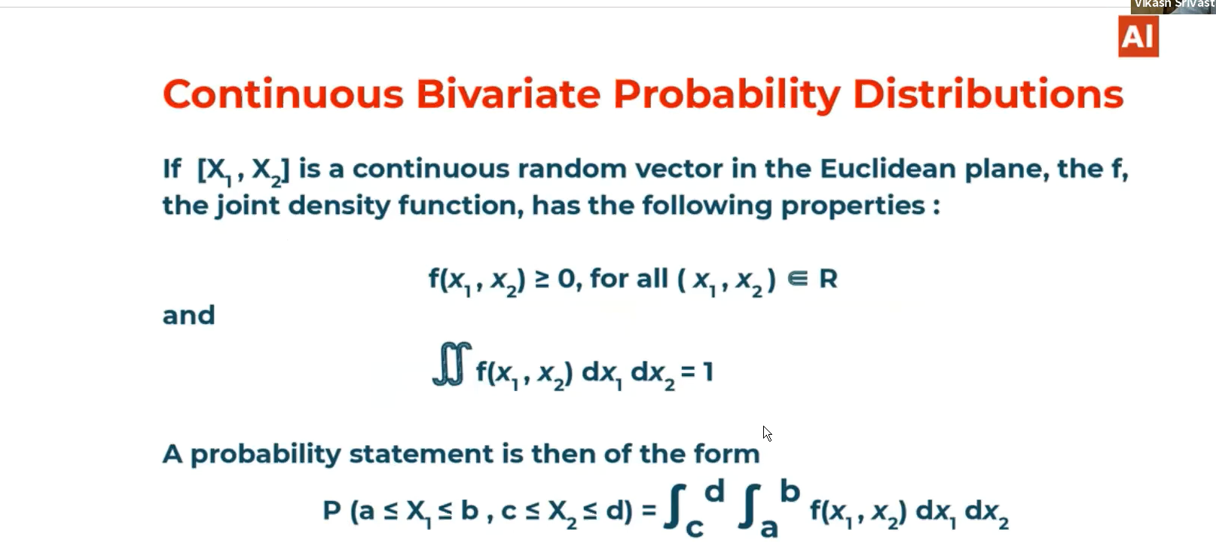

# Ex:

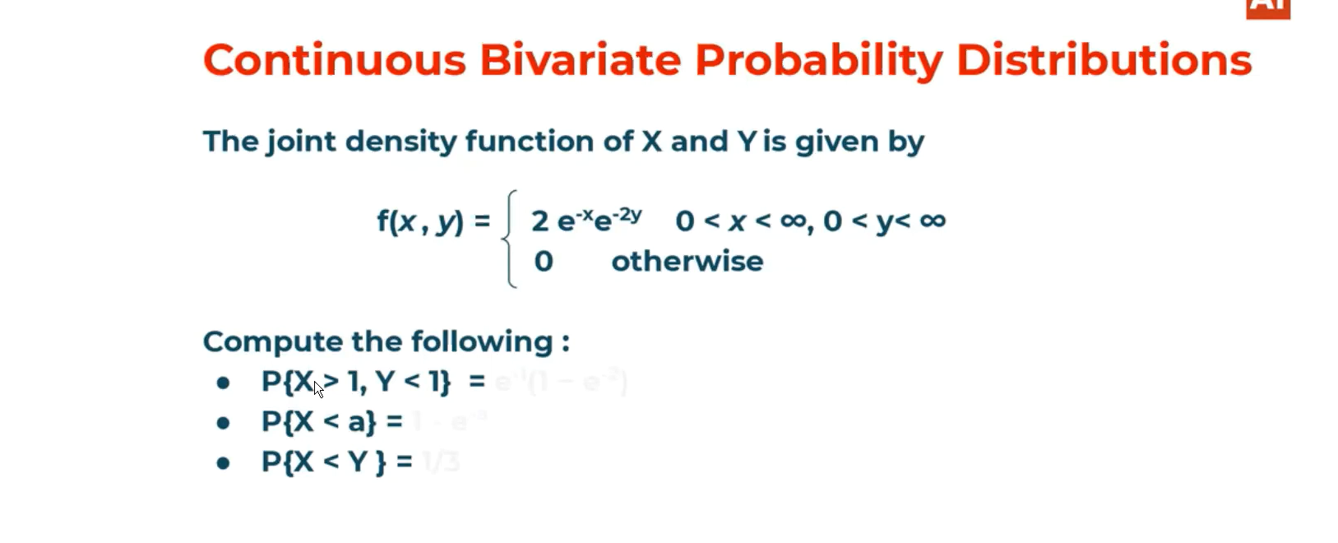

Ans:

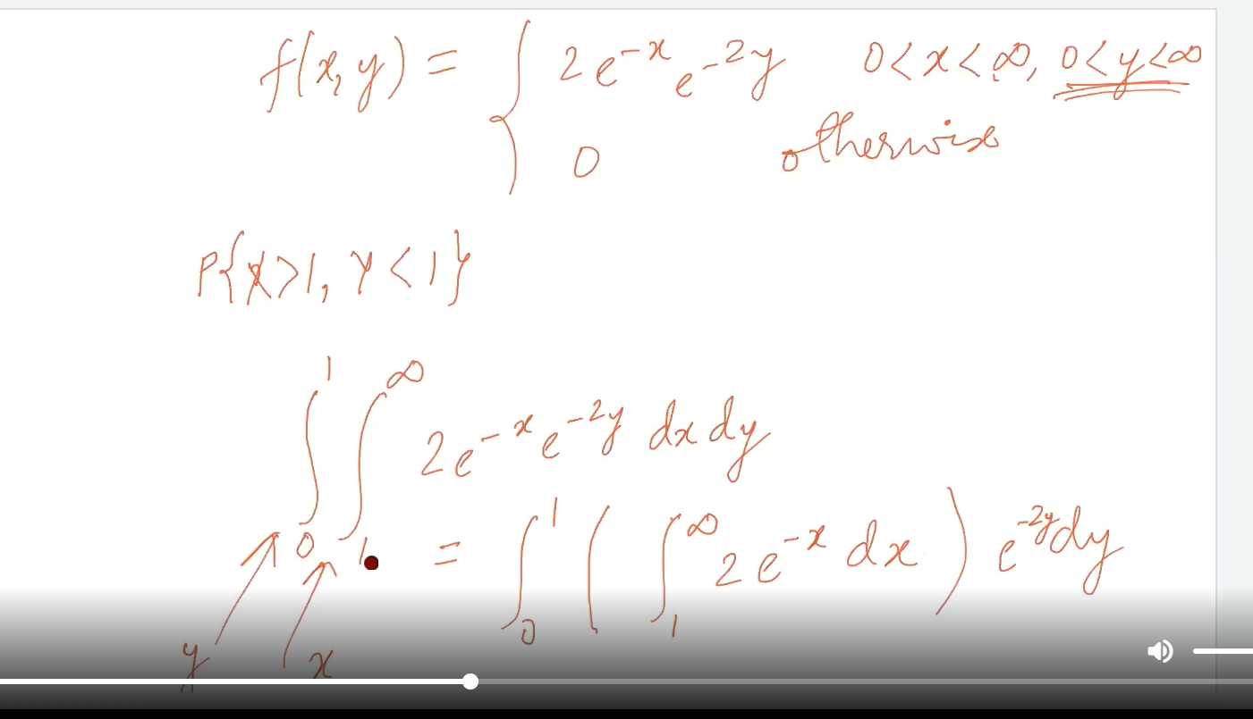

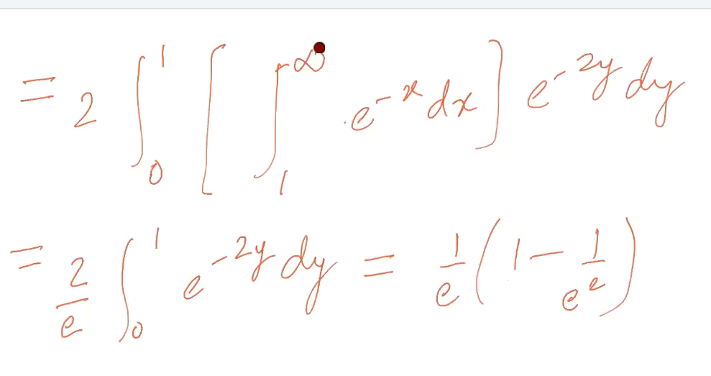

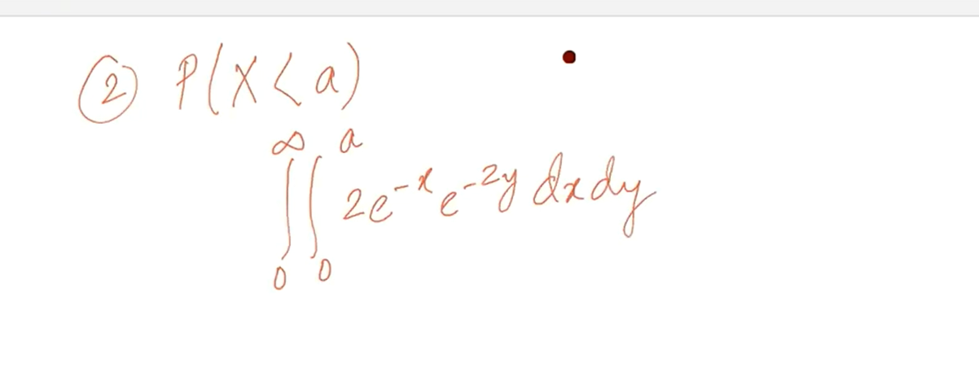

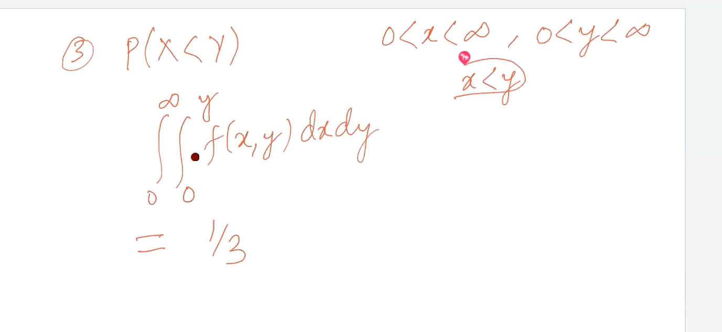

# Marginal distribution discrete case:

The marginal distribution is itself probability distribution.

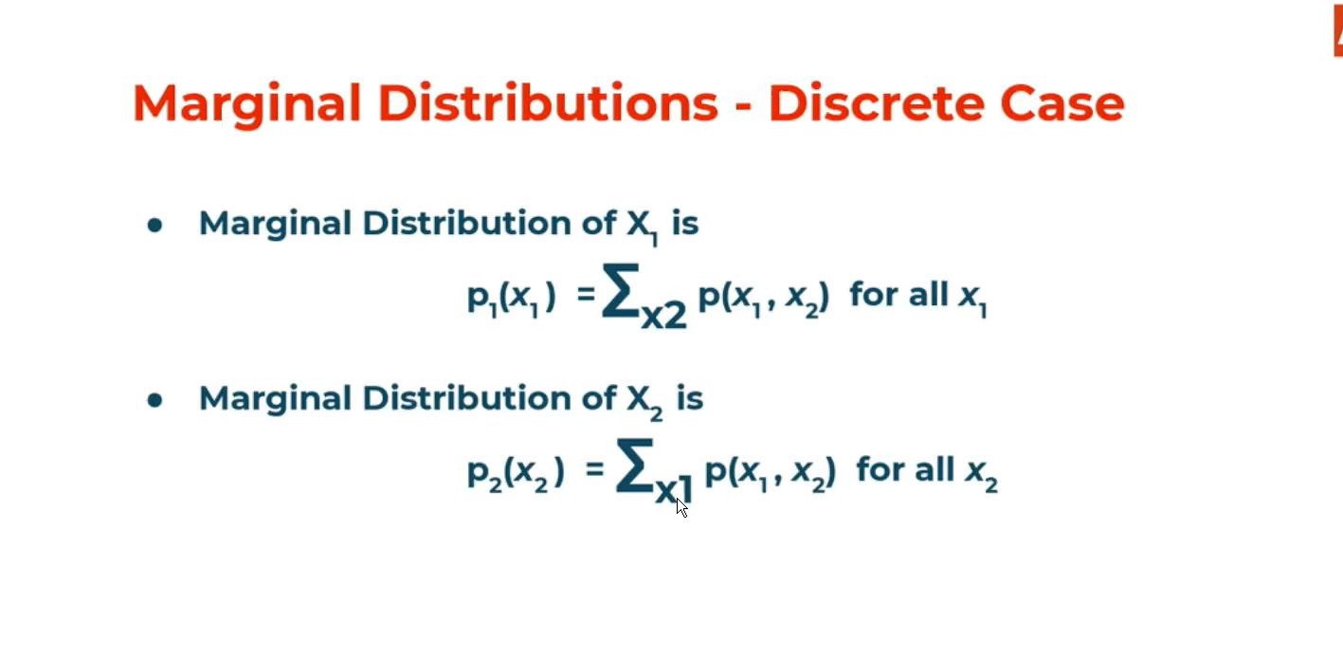

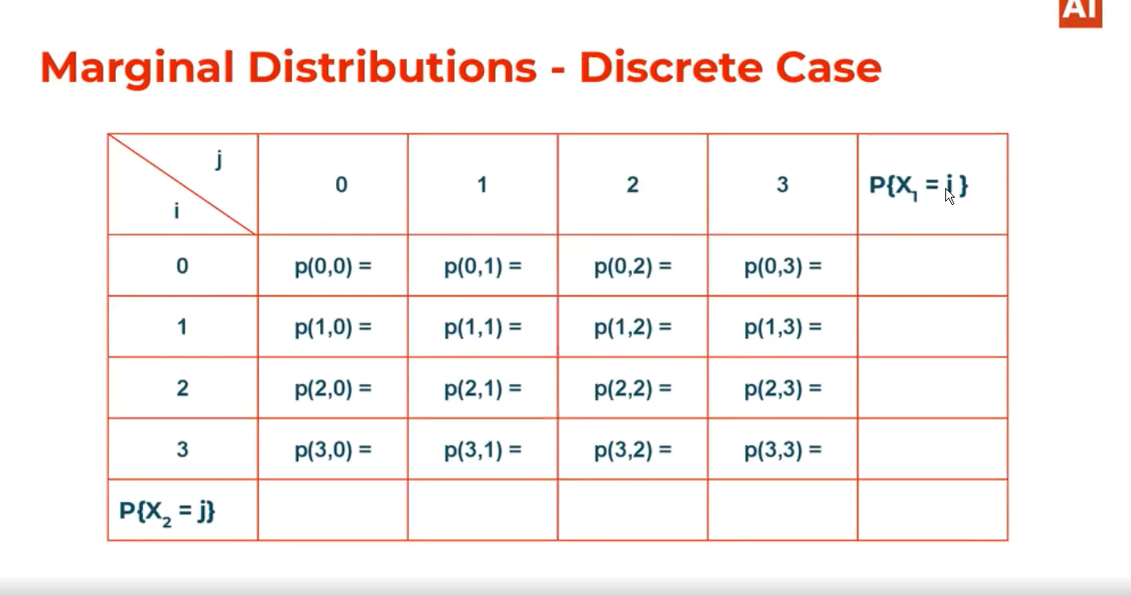

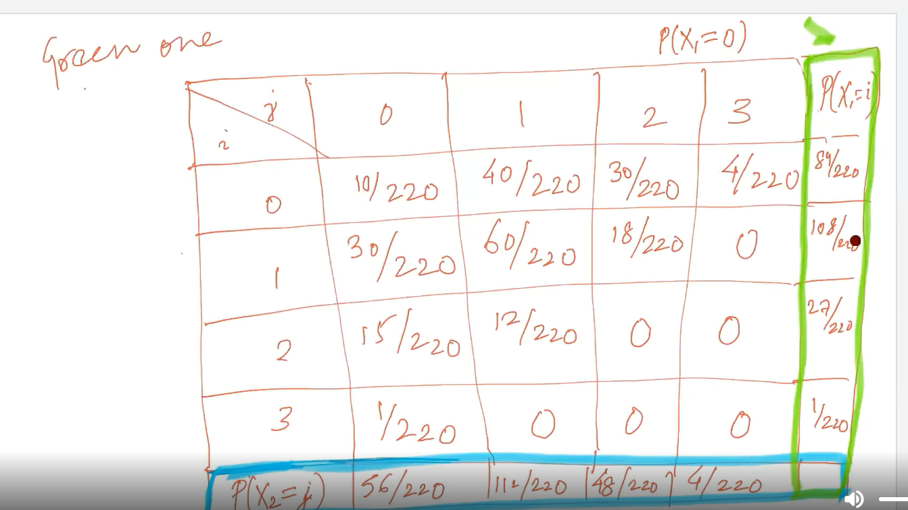

# Marginal distribution continuous:

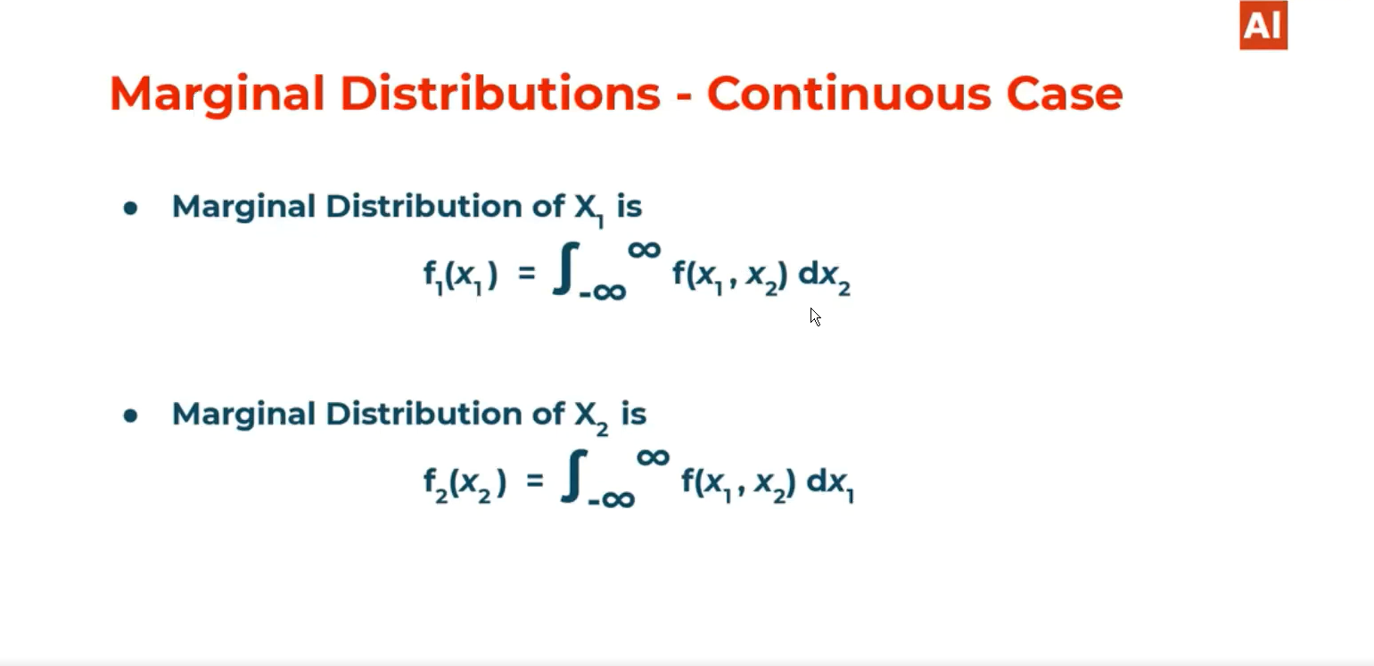

# Marginal distribution example:

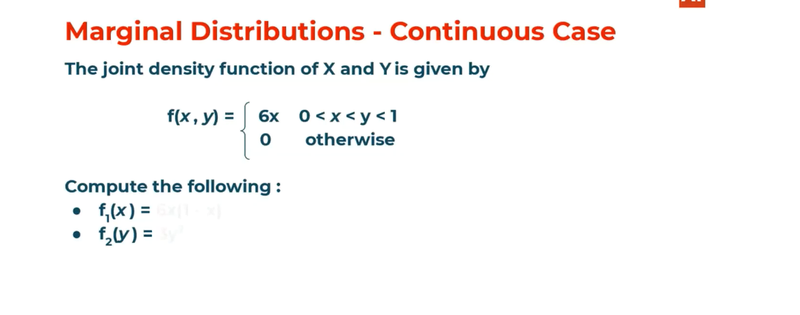

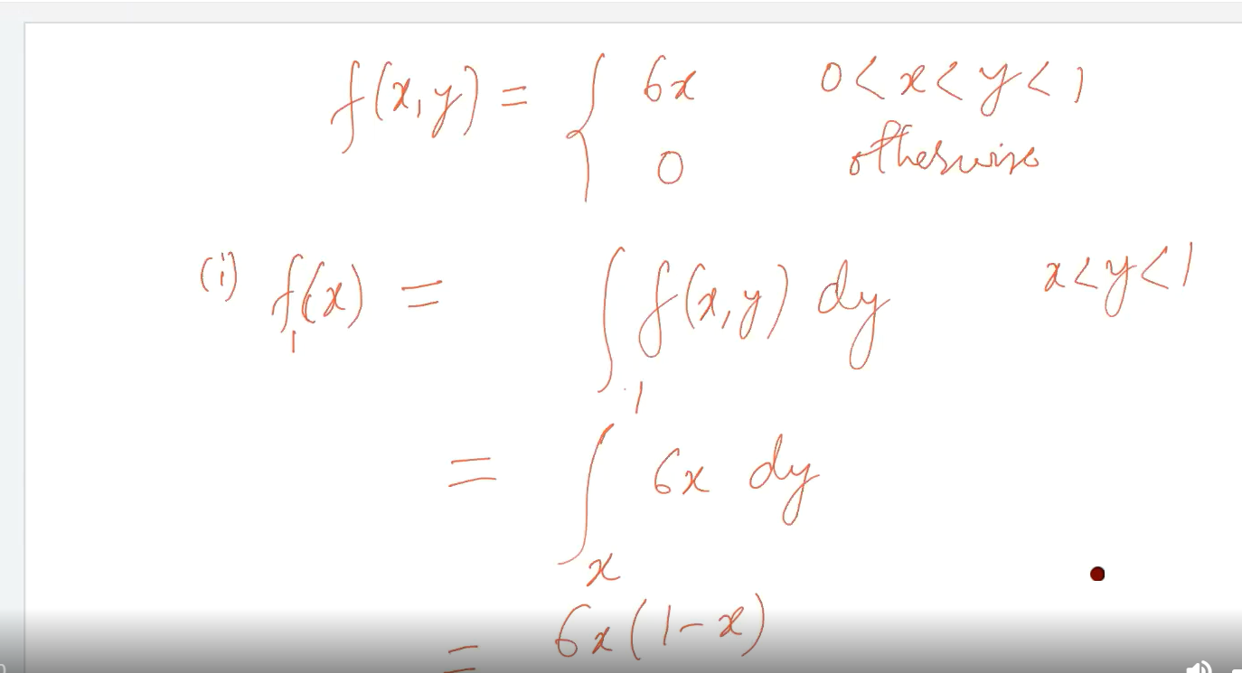

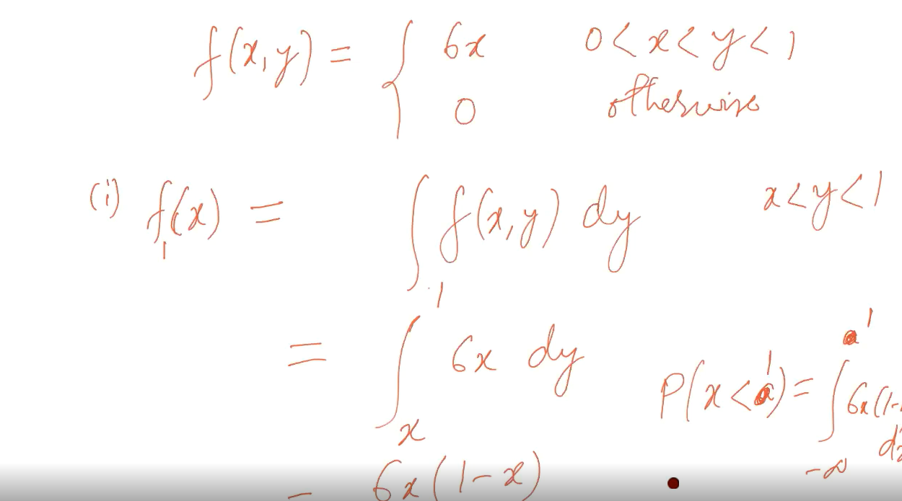

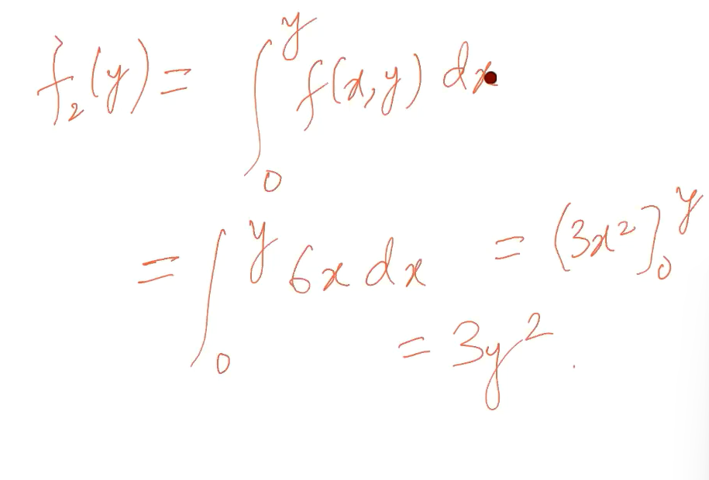

# Expectation and variance of a marginal distribution of discrete variable:

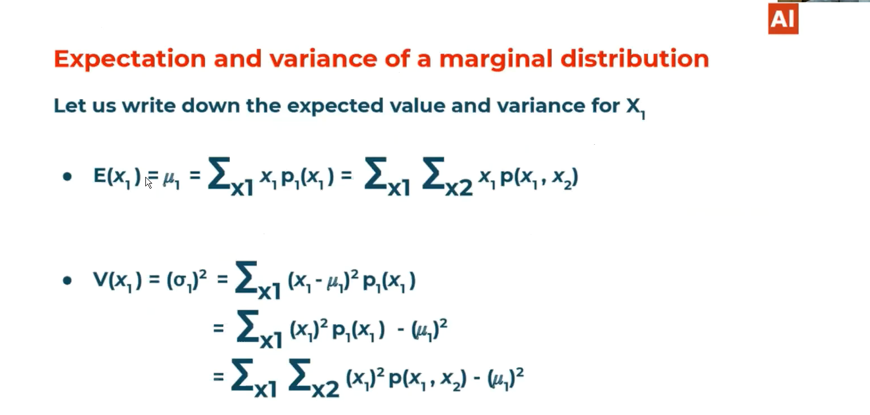

# Independent Random Variable for a discrete random variable:

Independent means if we change the value of any one variable then it should not affect the distribution of other variable.

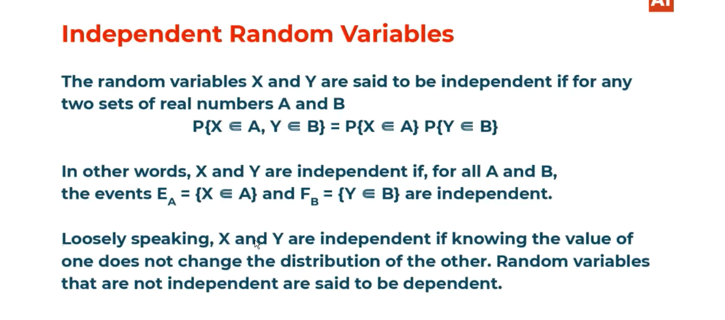

# Independent Random Variable for a continuous random variable:

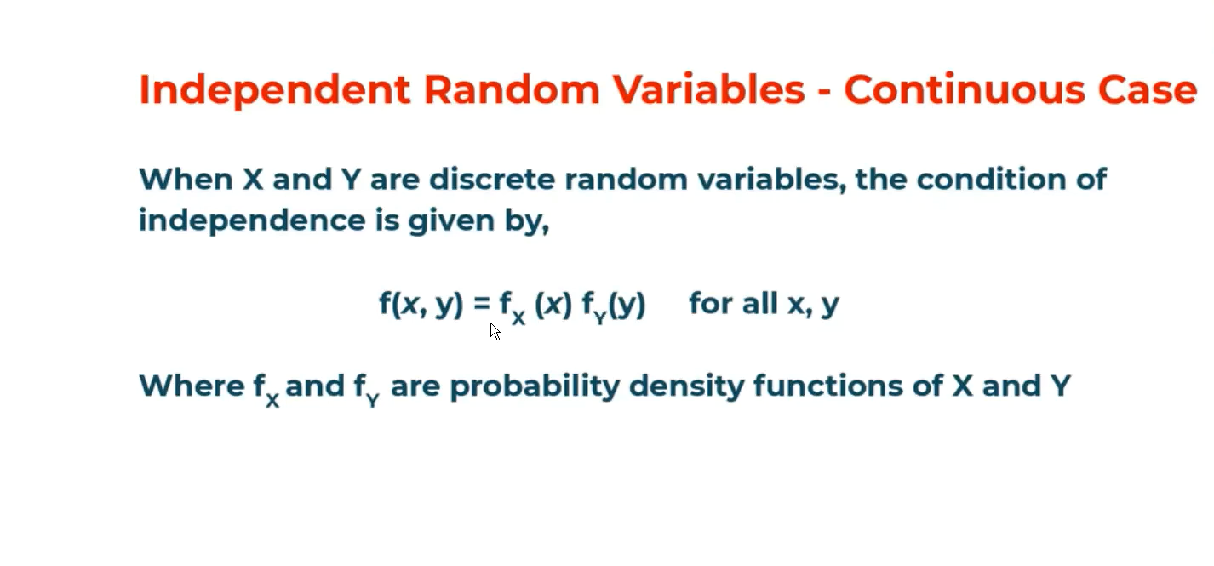

f(x,y)🡪 Joint probability distribution of x and y

fx(X)🡪 Marginal distribution of X

fy(Y)🡪 Marginal distribution of Y

# Example of independent random variable for discrete variable:

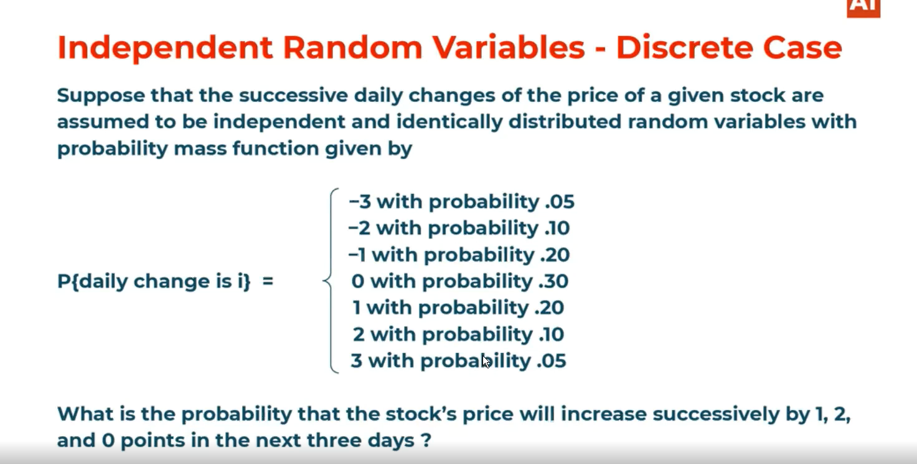

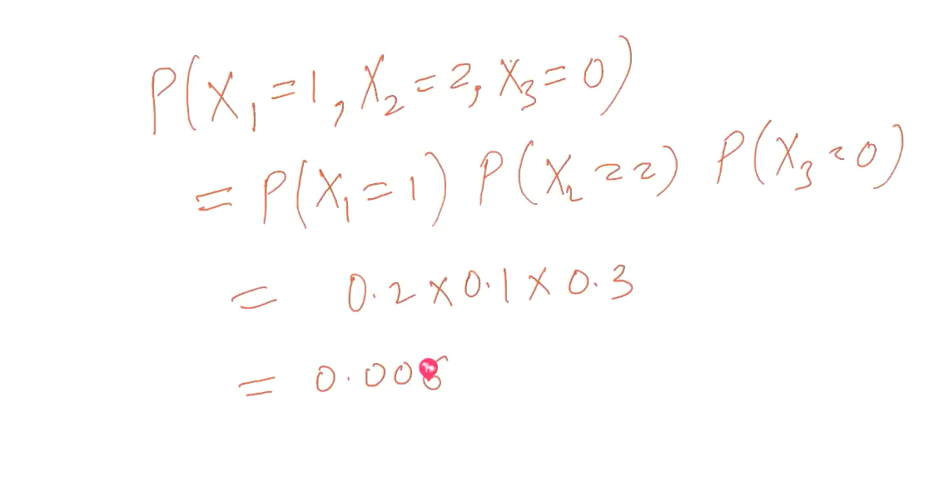

# Quiz:

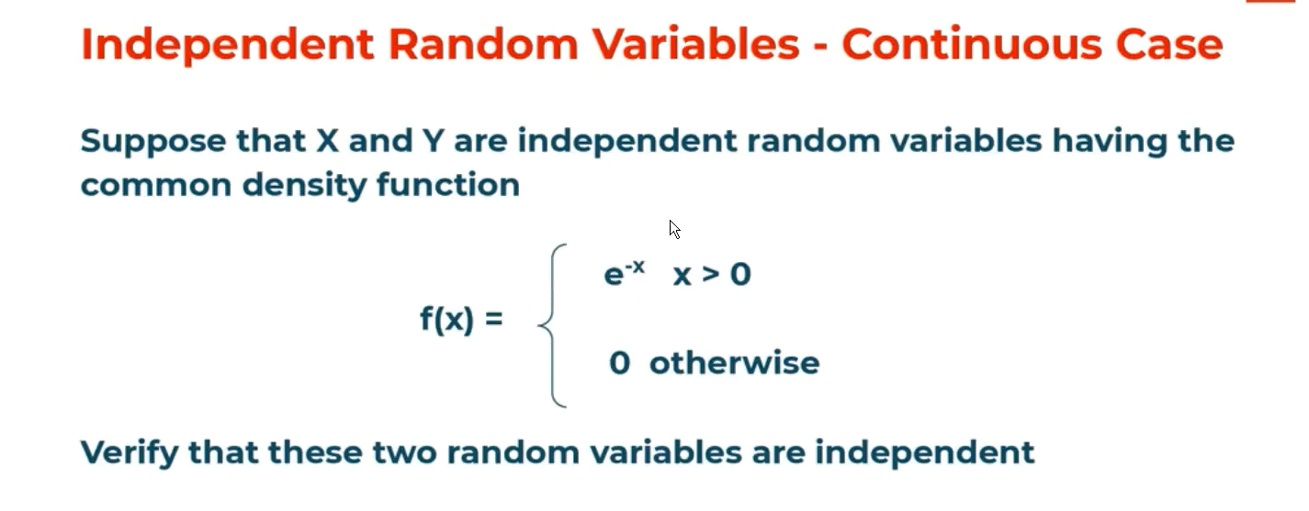

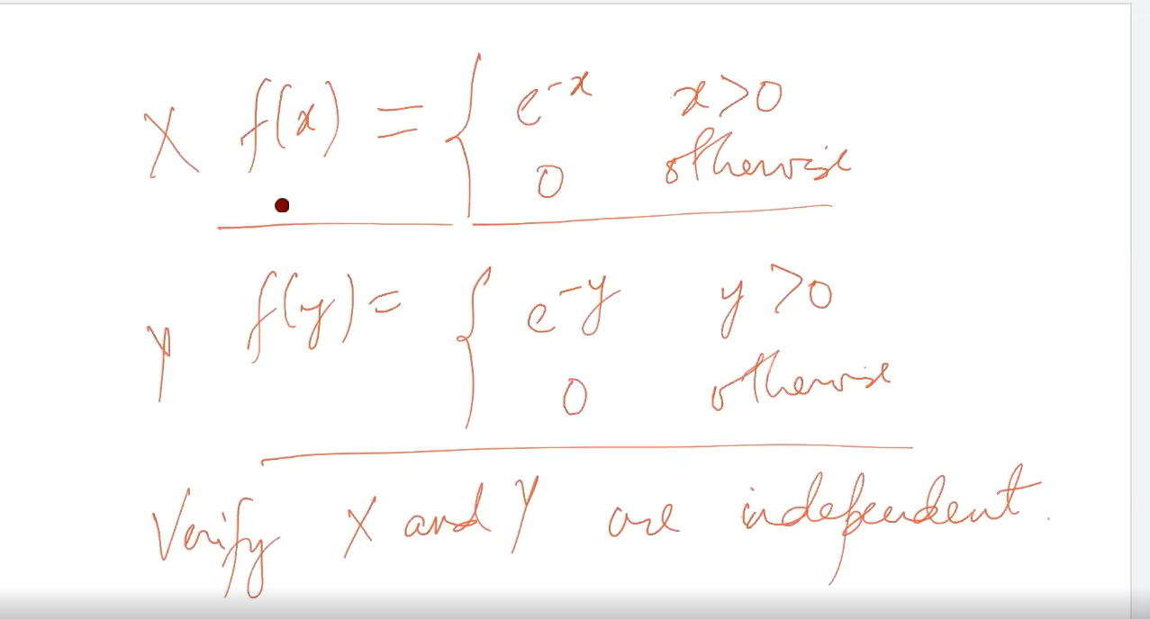

# Conditional probability of a joint probability mass function:

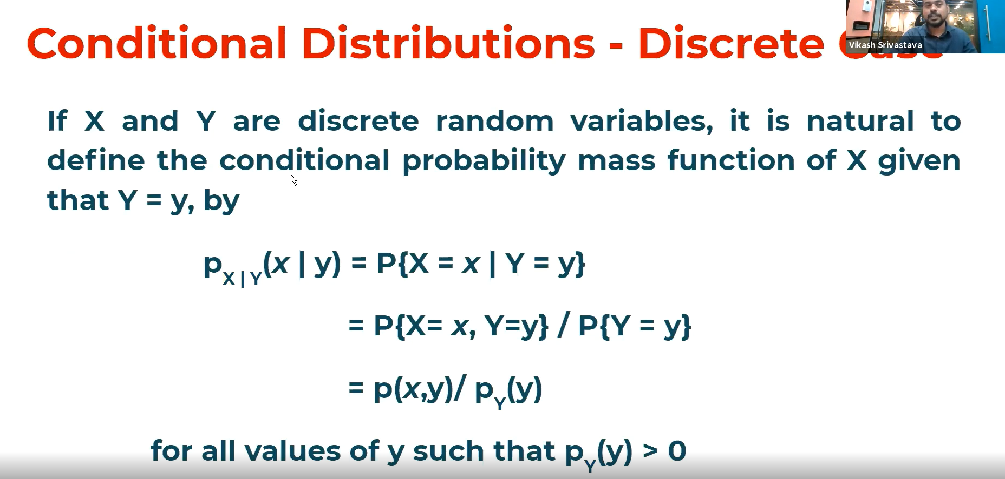

px(X,Y) 🡪 Joint probability mass function

py(Y)🡪 marginal probability mass function of Y

# example of conditional probability mass function:

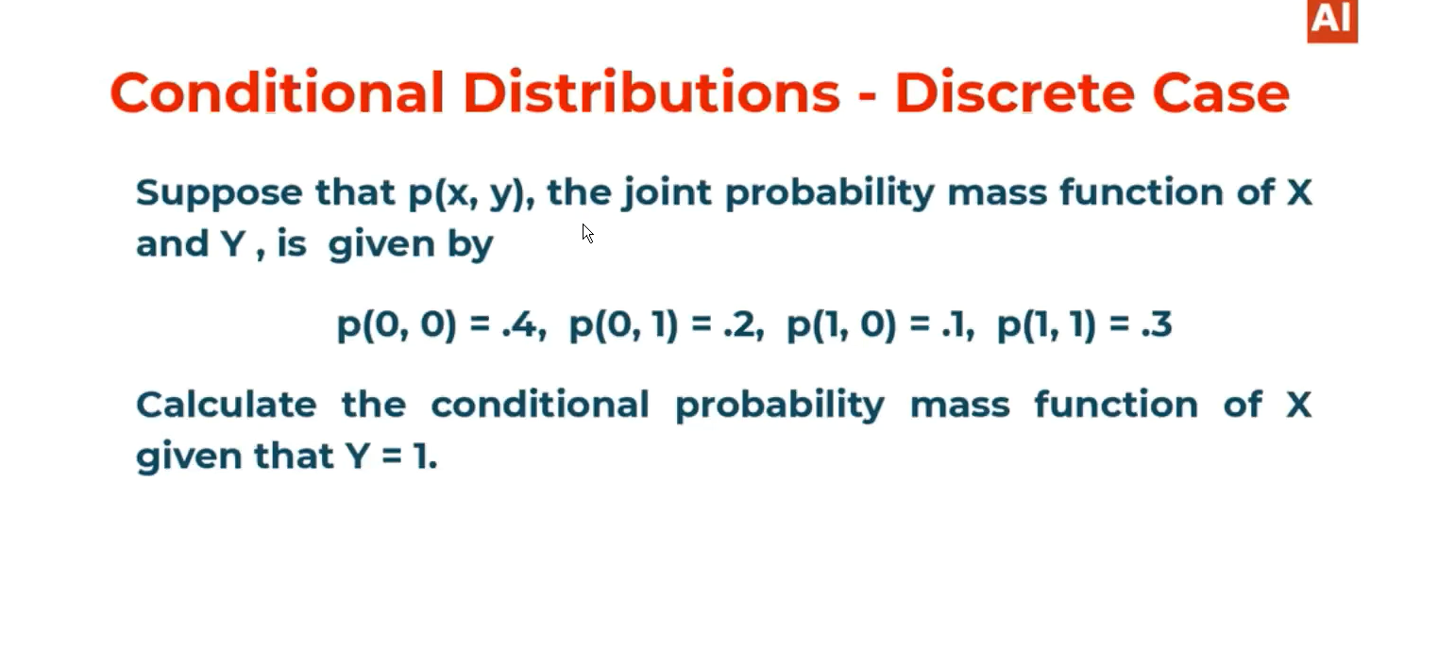

P(Y=1):

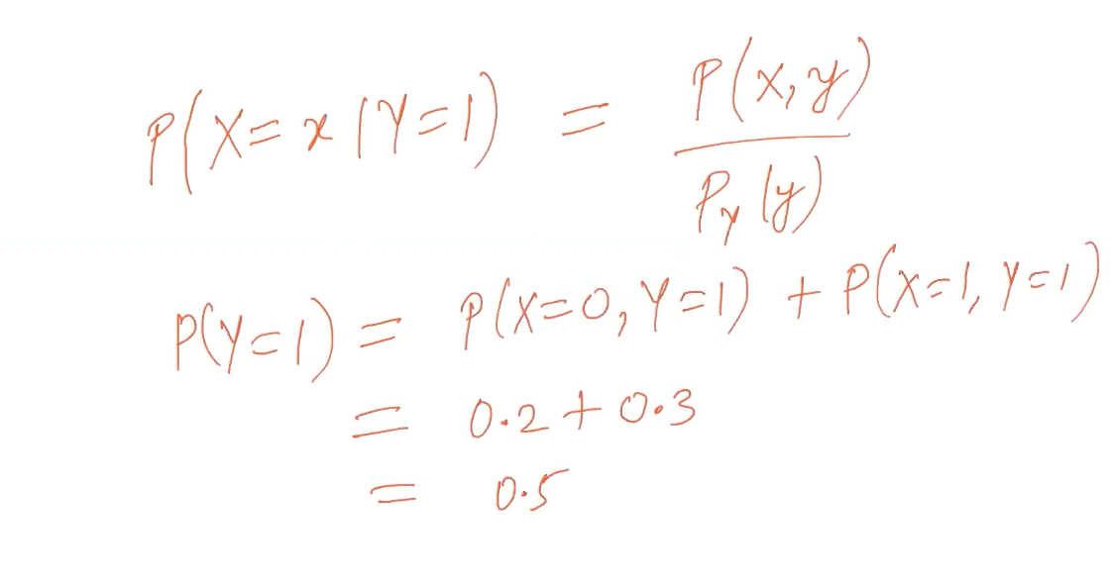

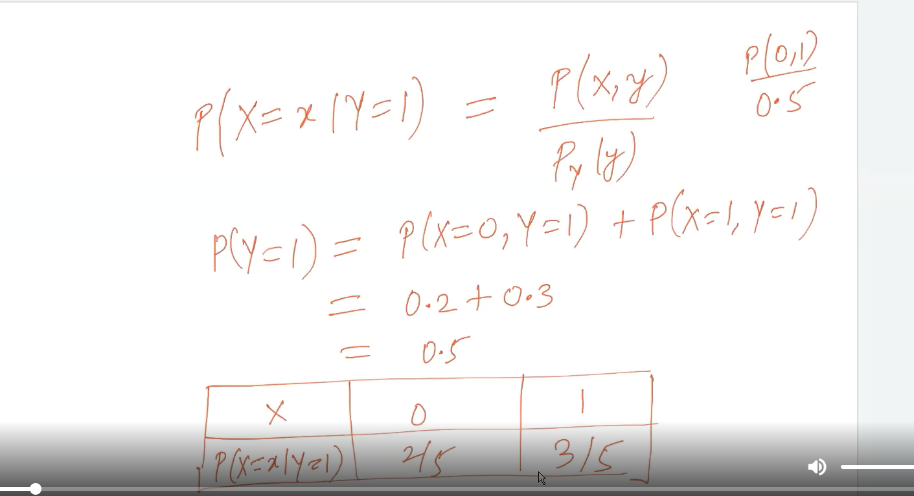

# Conditional distribution – continuous case

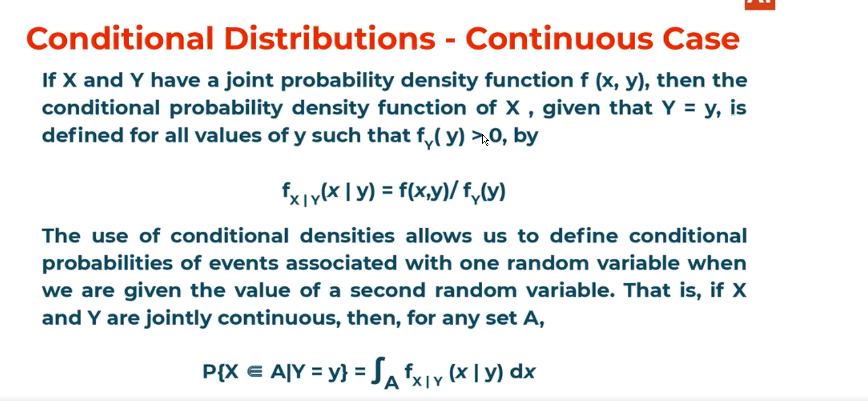

# Ex of continuous conditional distributional function: (Height of the person given calculate the persons weight)

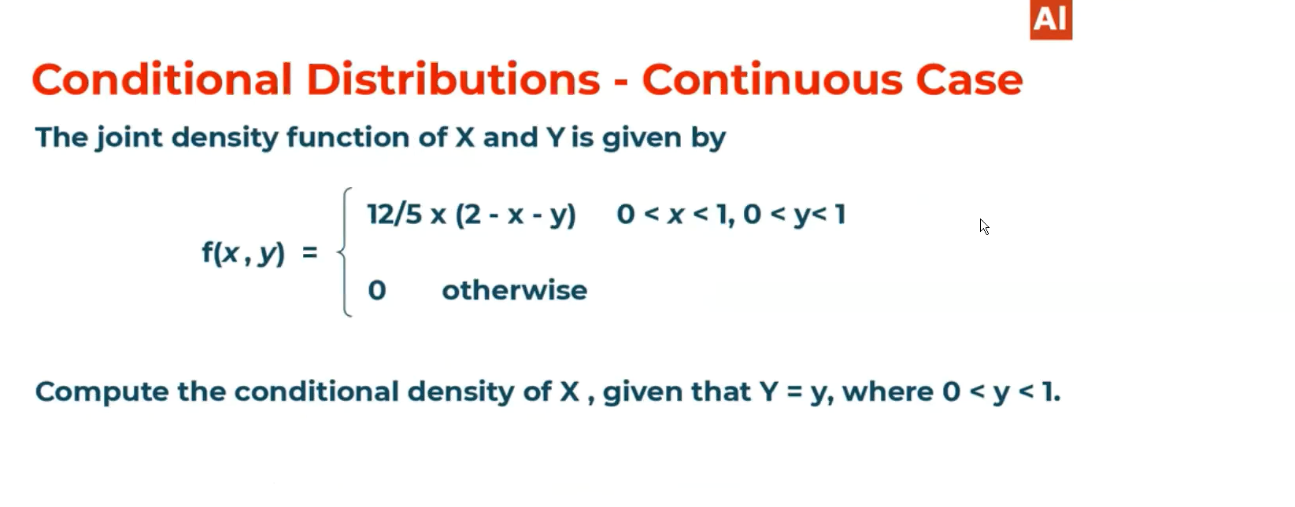

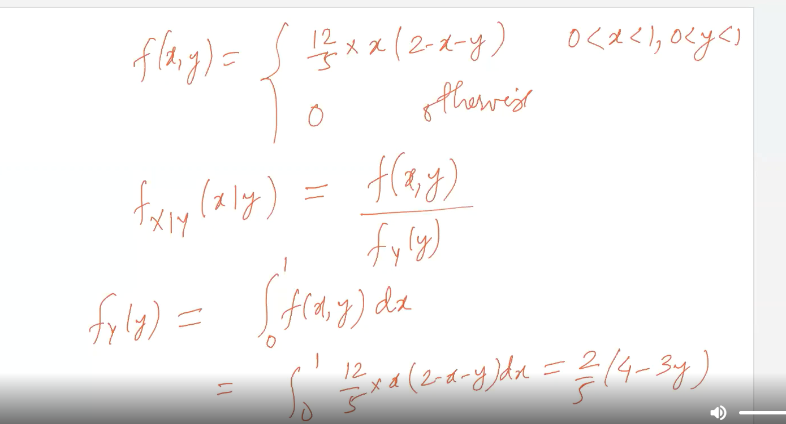

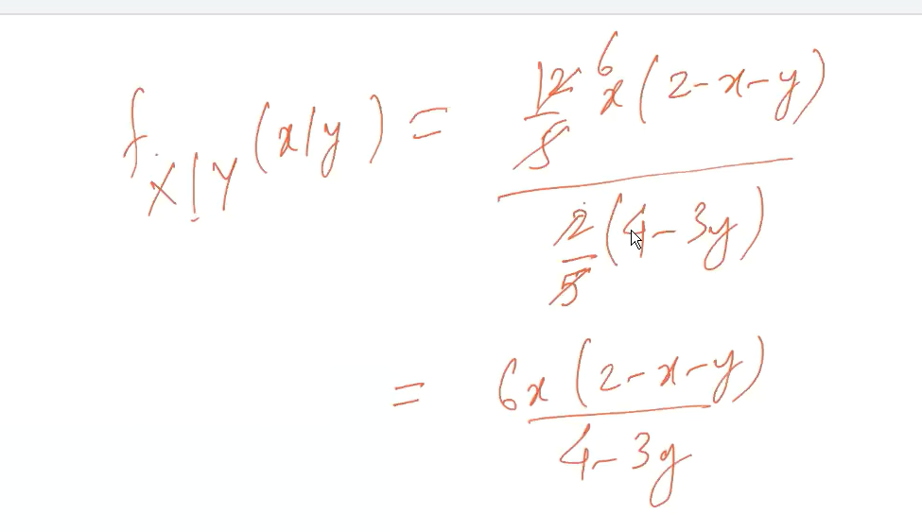

# Expectation of conditional probability mass function:

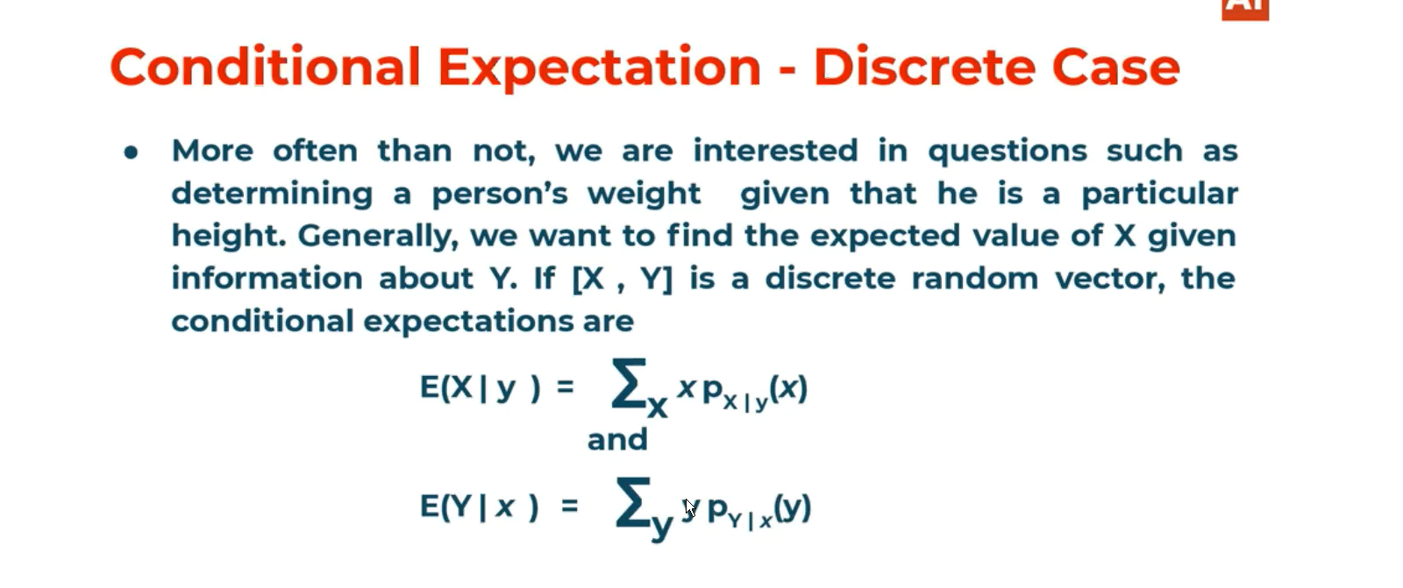

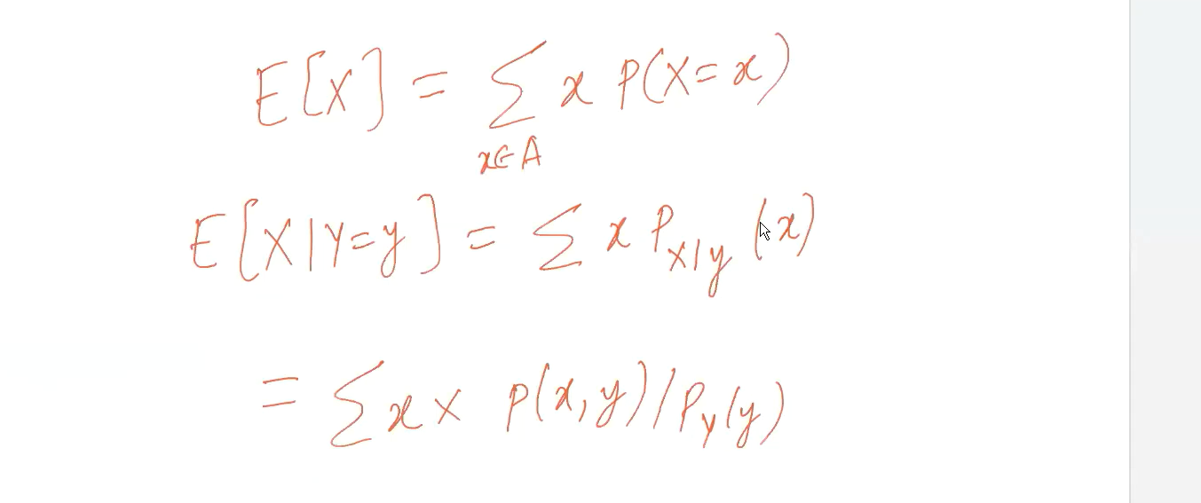

# Conditional expectation of Continuous case:

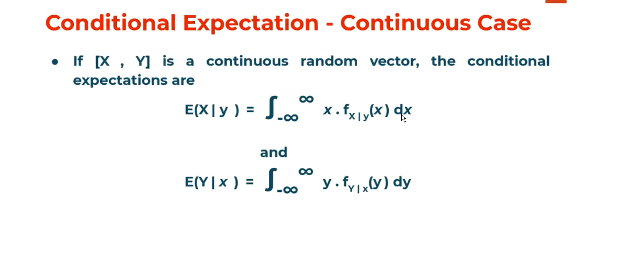

# Example for conditional expectation for probability dense function:

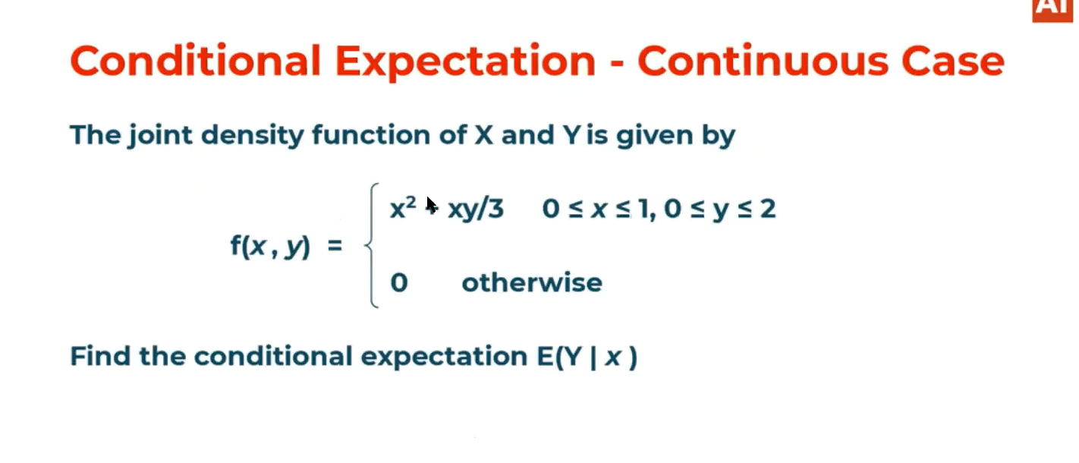

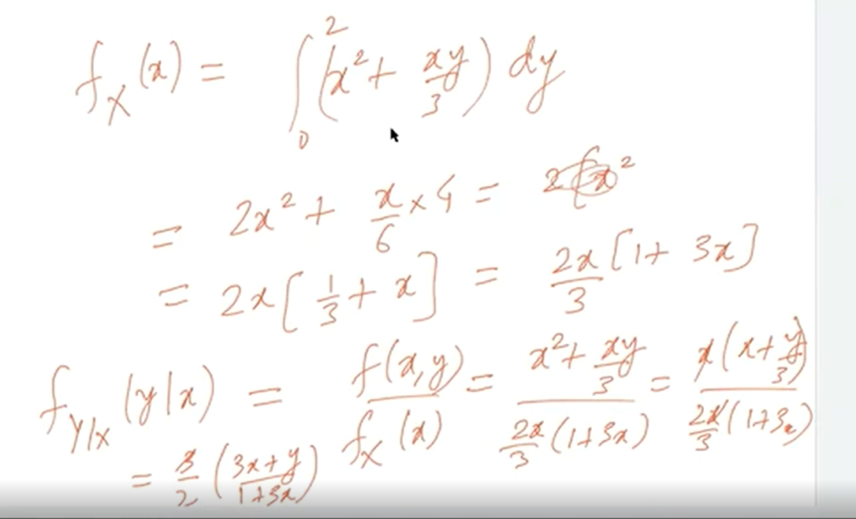

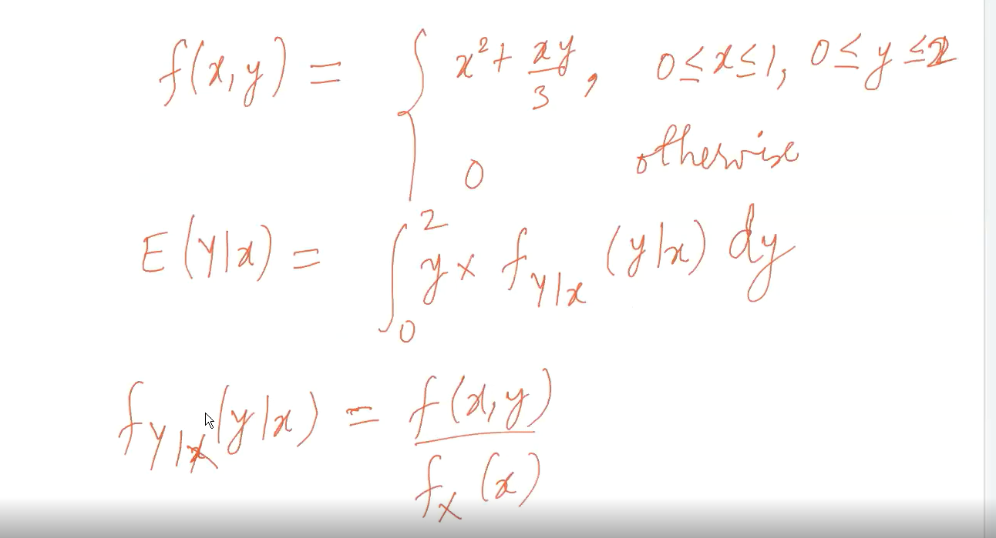

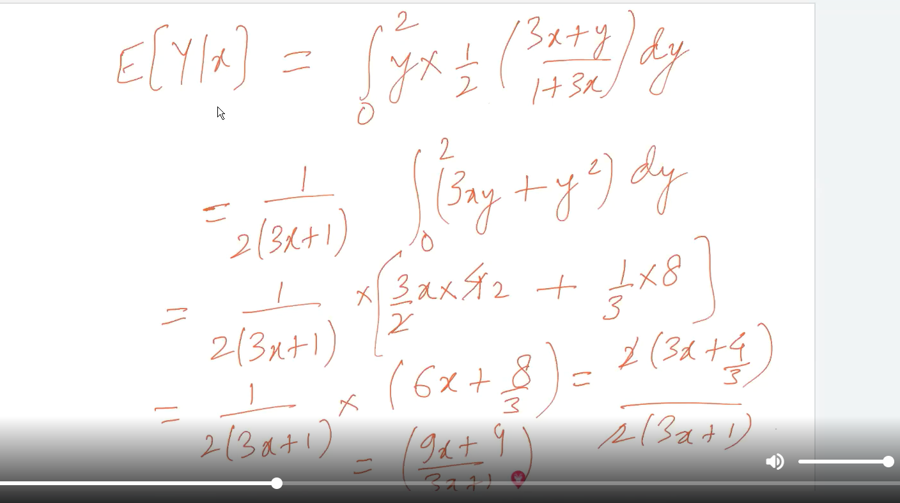

# The expectation of conditional probability E[y/x] is nothing but the function of x i.e considered as g(x):

🡪Because if we give inputs for X then we can calculate of Y.

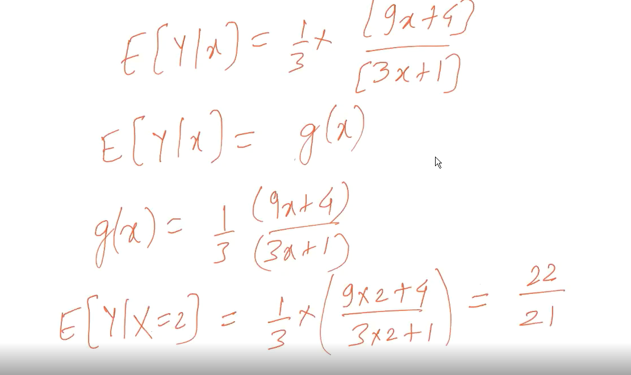

# Regression of the mean:

We had calculated E(x/y) which is nothing but the function of y so the function of the graph is called regress of x on y.

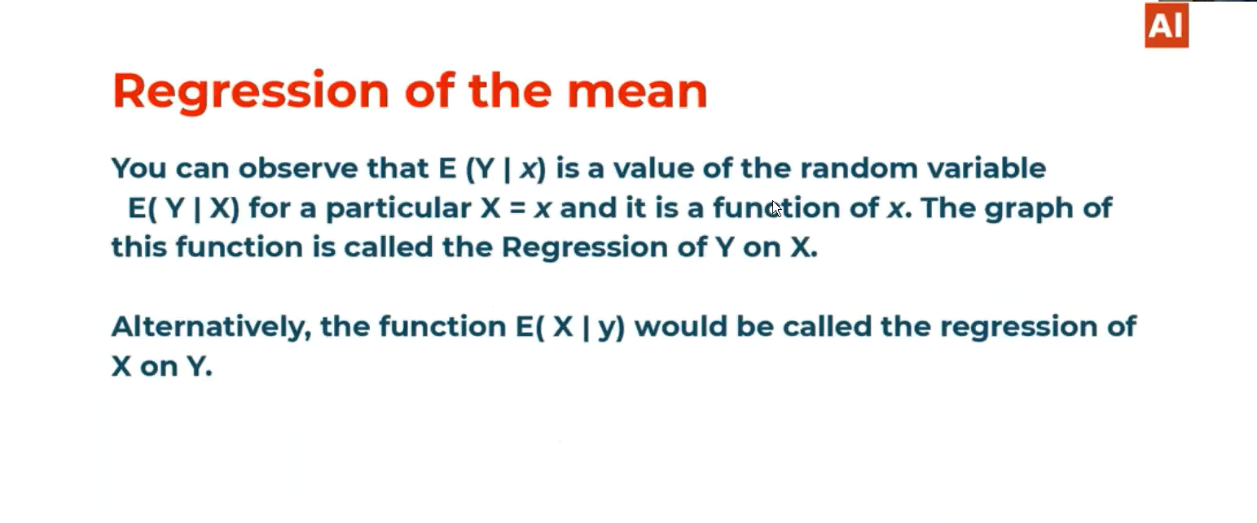

# Univariate Linear regression:

Any ML algorithm tasks is to map the values of x to its respective Y values. Just we need to find a function “f” which maps x values to y values.

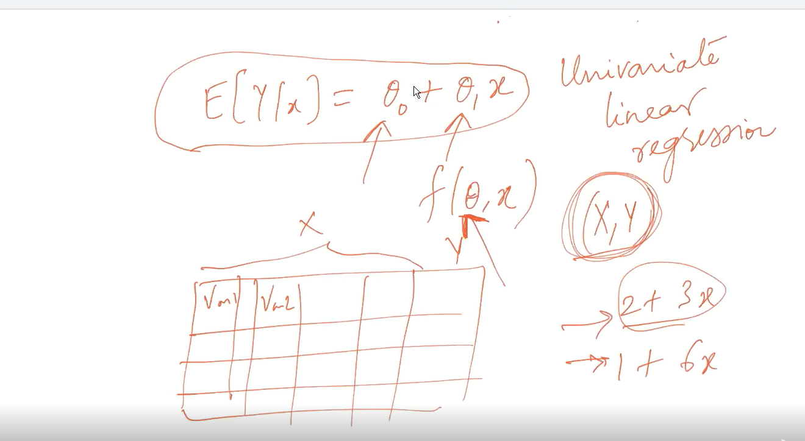

Math’s to ML example**:**

**If in the data sets if we are given the height of the persons and we are supposed to find out the expected wight of the persons then it would be considered as we are calculating the probability density function of weight given height which is conditional probability density function. And we apply expectation for all the values of height so we can calculate weight of the persons.**

# Degree of associations:

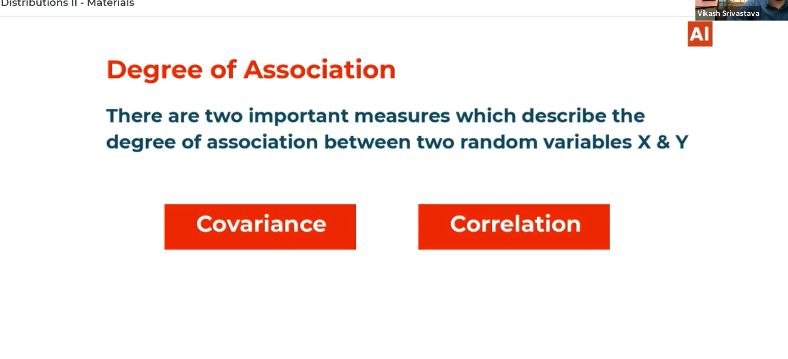

# Covariance:

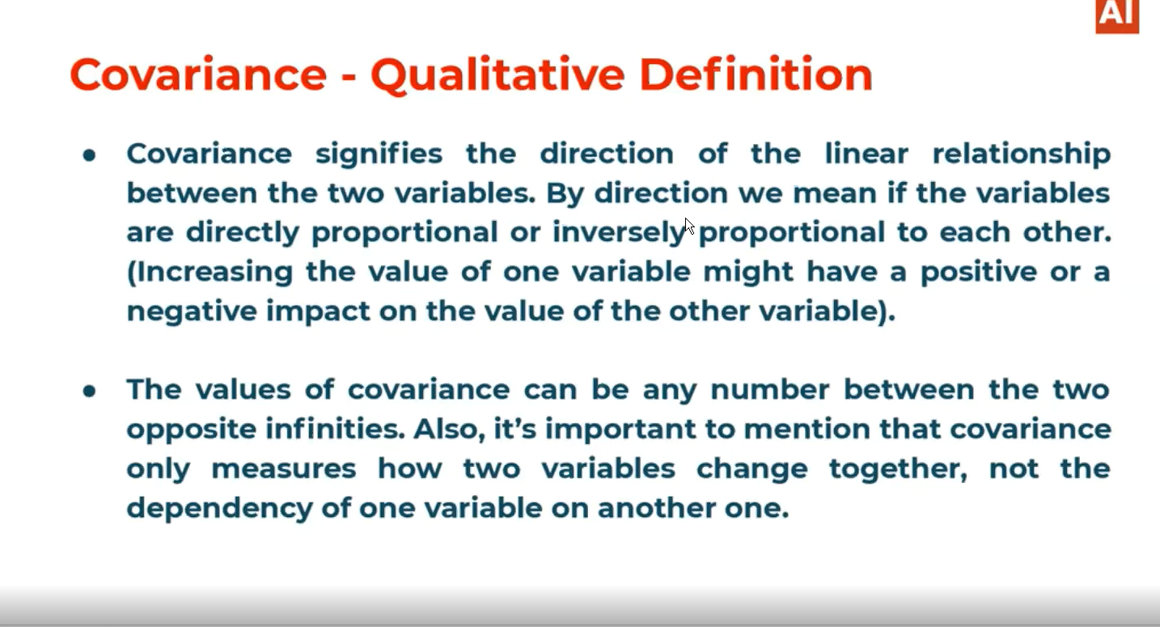

# It give the direction for the relation between 2 variables. If the variables are not linearly related then its not mean that their covariance is not there.

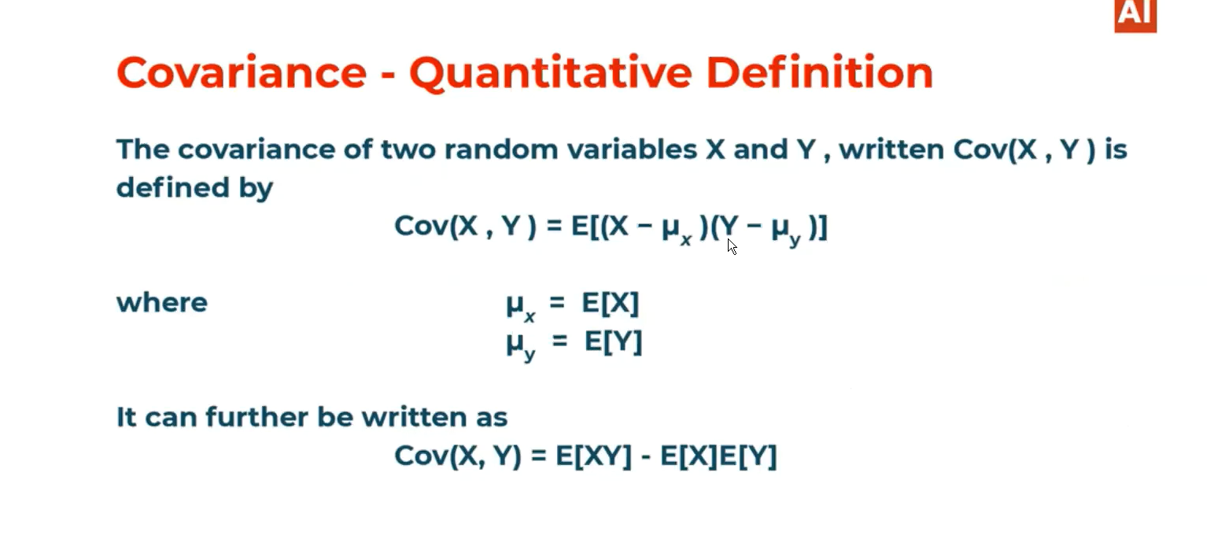

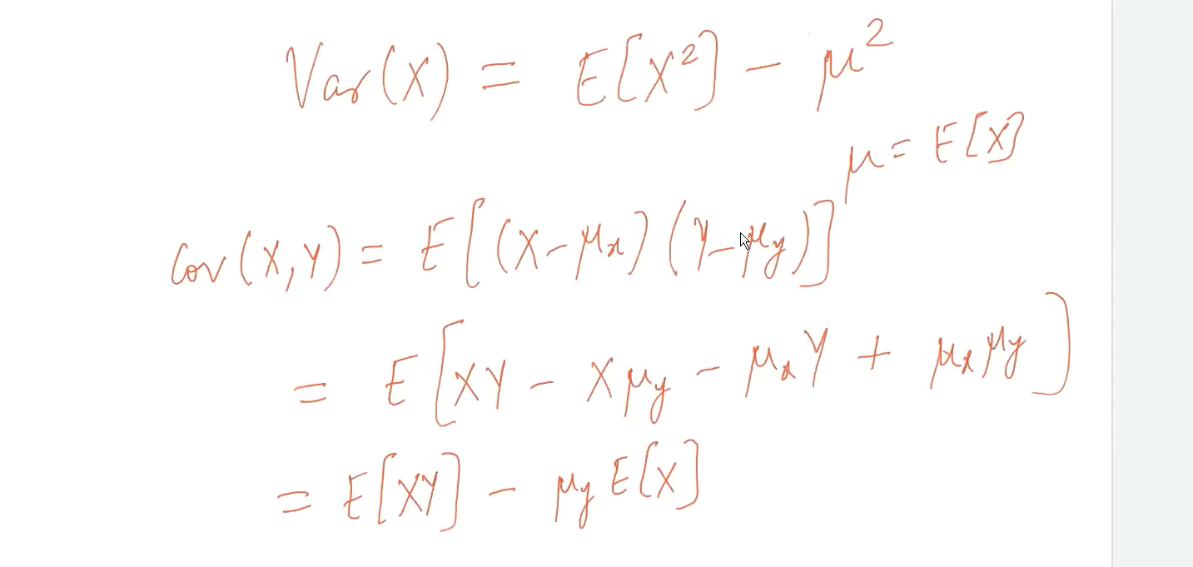

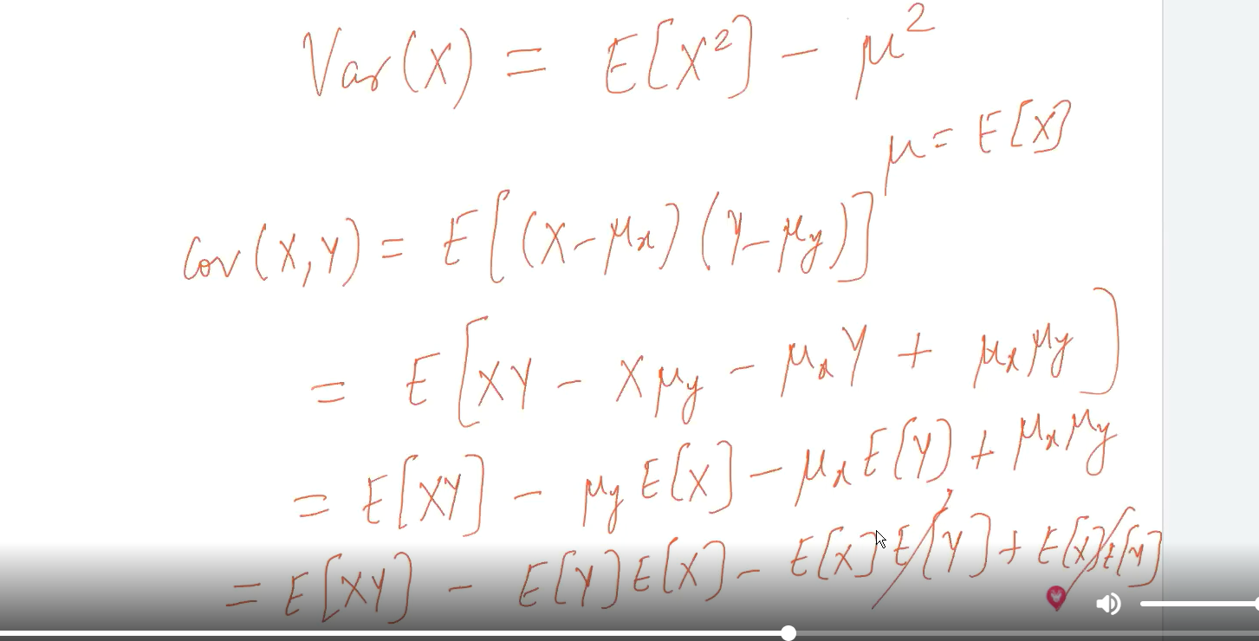

# Covariance is zero it means the variables are independent from each other we can see in below scenario: Relation between marginal distribution and joint distribution

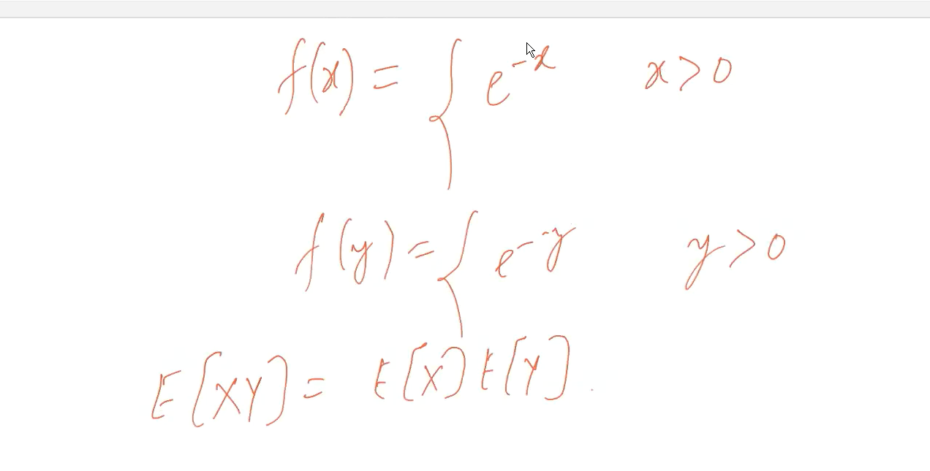

# Properties of covariance, Covariance of the same variable is equal to the variance of the variable:

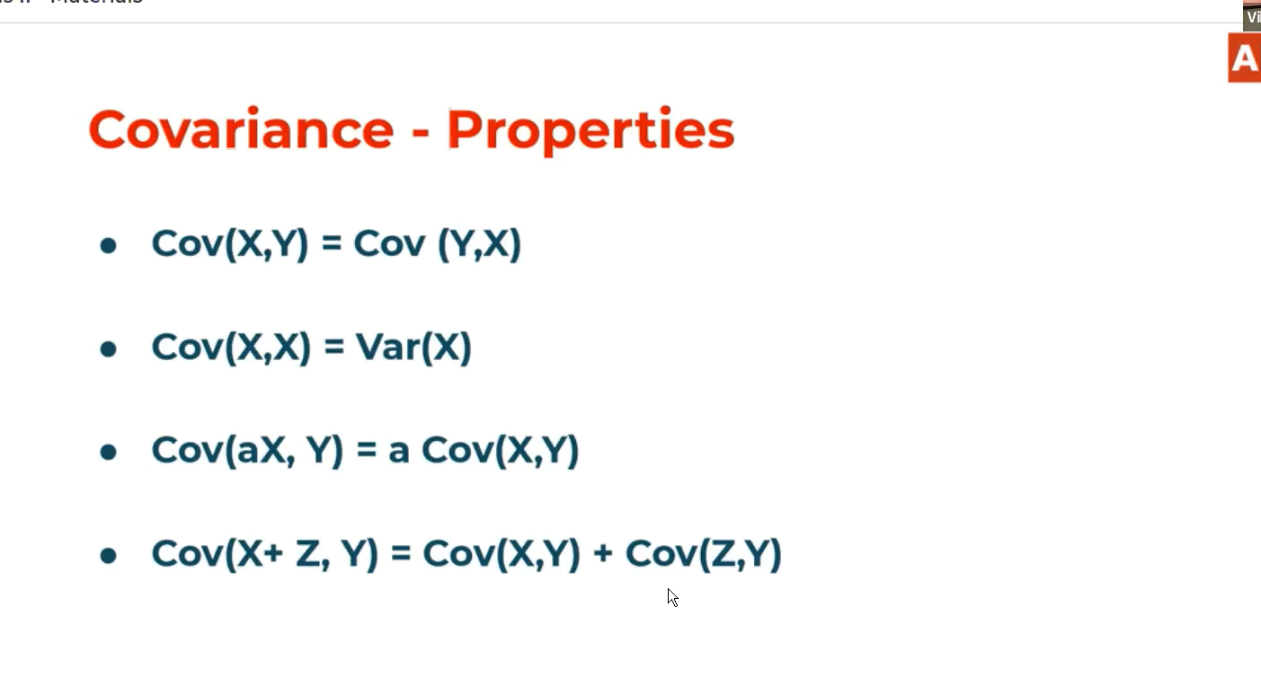

Correlation: It defines the strength between two random variables means how the variables are mapped with each other.

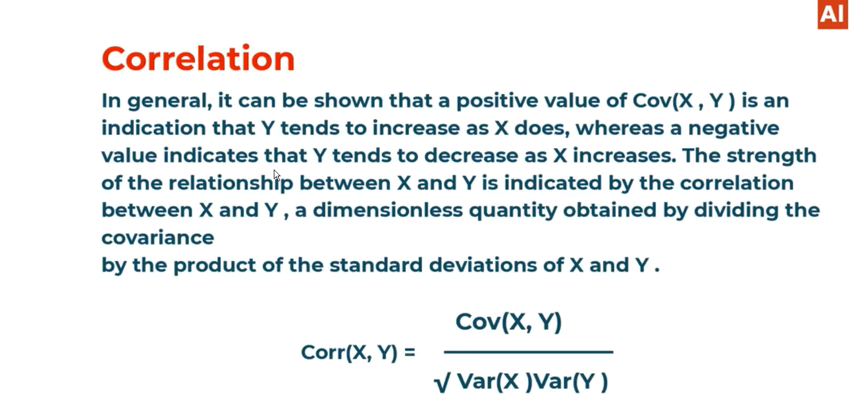

# Correlation example:

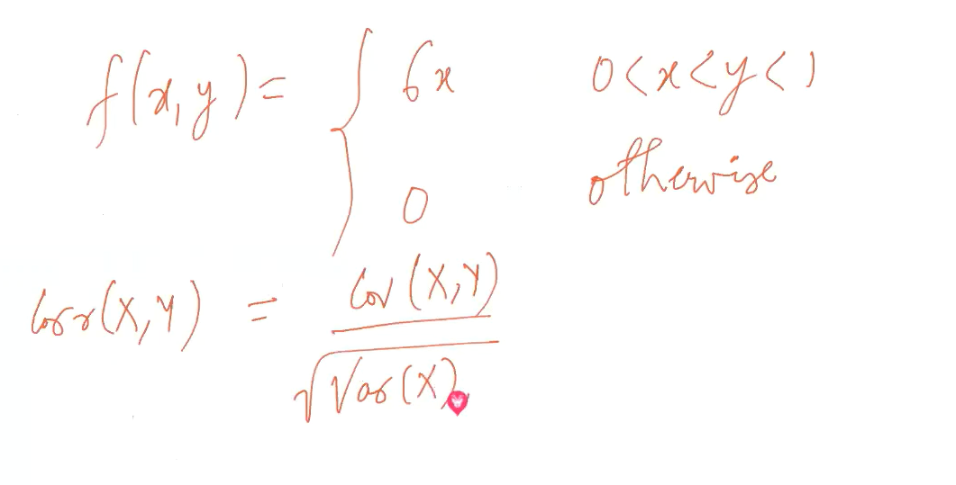

# We need to find below quantities:

